**A PROJECT REPORT**

**ON**

Stockplus

**SUBMITTED TO THE SAVITRIBAI PHULE PUNE UNIVERSITY, PUNE**

**IN THE PARTIAL FULFILLMENT FOR THE AWARD OF THE DEGREE**

**OF**

**BACHELOR OF BUSINESS ADMINISTRATION**

**IN**

**COMPUTER APPLICATION**

**BY**

Kamlesh Ramdas Adsul Examination Seat No. :

Sarthak Kailas Avachat Examination Seat No. :

**UNDER THE GUIDANCE OF**

Prof. Watpade A.S.



**Year 2025-26**

**  **

***Rayat Shikshan Sanstha's***

**S. M. JOSHI COLLEGE, PUNE**

**HADAPSAR, PUNE 411028**

**DEPARTMENT OF COMPUTER SCIENCE AND APPLICATION**

**2025-26**

**CERTIFICATE**

This is to certify that the project report entitled

Stockplus

**Submitted by**

Kamlesh Ramdas Adsul Examination Seat No.:

Sarthak Kailas Avachat Examination Seat No.:

is a bonafide work carried out by them under the supervision of **Prof. Watpade A.S.** and it is approved for the partial fulfillment of the requirement of Savitribai Phule Pune University for the award of the Degree of **Bachelor of Business Administration in (Computer Application).**

This project report has not been earlier submitted to any other Institute or University for the award of any degree or diploma.

**Prof. Watpade A. S. Hon. Sangeeta Yadav**

Project Guide HOD

**Internal Examiner** **External Examiner**

**ACKNOWLEDGEMENT**

We feel great pleasure in expressing our deepest sense of gratitude and sincere thanks to our guide **Prof. Watpade A.S.** for their valuable guidance during the Project work, without which it would have been a difficult task. I have no words to express my sincere thanks for valuable guidance, extreme assistance and cooperation extended to all the Staff Members of our department.

This acknowledgement would be incomplete without expressing our special thanks to **Hon. Sangeeta Yadav,** Head of the Computer Application department for her support during the work.

We would also like to extend our heartfelt gratitude to our Principal, **Dr. S. T. Salunkhe** who provided a lot of valuable support, mostly being behind the veils of college bureaucracy.

Last but not the least we would like to thank all the Teaching, Non-teaching staff members of our Department, our Parents and our colleagues those who helped us directly or indirectly for completion of this project successfully.

Kamlesh Ramdas Adsul

Sarthak Kailas Avachat

**INDEX**

**Sr.No Chapter Name** **PageNo.**

**1 Abstract 1**

**2 Introduction 3**

2.1 Motivation

2.2 Problem Statement

2.3 Purpose/Objective and Goals

2.4 Literature Survey

2.5 Project Scope & Limitation

**3 System Analysis 6**

3.1 Existing System

3.2 Scope and Limitations

3.3 Perspective and Features

3.4 Stakeholders

3.5 Requirement Analysis

**4 System Design 10**

4.1 Design Constraints

4.2 System Model: DFD

4.3 Data Model

4.4 User Interfaces

**5 Implementation Details 24**

5.1 Software Requirements

5.2 Hardware Requirements

**6 Outputs and Report Testing 26**

6.1 Test Cases

6.1.1 Black Box Testing

6.1.2 White Box Testing

**7 Conclusion & Recommendations 35**

7.1 Conclusion

7.2 Recommendations

**8 Future Scope 37**

**9 Bibliography & References 39**

**CHAPTER 1:**

**ABSTRACT**

1

1

**ABSTRACT**

StockPlus is a comprehensive and user-friendly stock trading application designed to empower individual investors and traders with real-time market insights, trading tools, and portfolio management capabilities. This application provides a secure and efficient platform for buying and selling stocks, analyzing trends, and makinginformed investment decisions.

The core features of StockPlus include real-time stock price updates, interactive charts, technical analysis indicators, trade execution, watchlists, and personalized alerts. The platform integrates advanced data visualization and predictive analytics to assist users in identifying market opportunities. In addition, it supports user authentication, transaction history tracking, and portfolio performance monitoring, ensuring both functionality and security.

2

**CHAPTER 2:**

**IMTRODUCTION**

3

**2.1 Motivation**

Many people want to trade stocks, but most trading apps are either too hard for beginners or too basic for experienced traders. This makes it difficult for people to start trading or make smart decisions.

StockPlus is an app that solves this problem. It is easy to use for beginners while also offering powerful tools for advanced traders. Users can learn, trade, track the market, and get alerts safely and anytime. The goal is to make trading simple, smart, and reliable for everyone.

**2.2 Problem Statement**

Most stock trading apps are either too complicated for beginners or too basic for experienced traders. Beginners often get confused by complex features, while advanced users need tools like real-time data, charts, and portfolio tracking. There are very few platforms that combine simplicity with advanced features, and some apps may not show live stock prices properly or lack security and user-friendliness. Because of this, many students and young investors avoid trading or make poor decisions due to a lack of proper tools and information. **StockPlus** aims to solve these problems by offering an easy-to-use, secure, and feature-rich trading application that helps both beginners and experienced users manage their stock investments confidently.

**2.3 Purpose/Objective and Goals**

**Purpose / Objective:**

The main purpose of the StockPlus project is to provide a simple, secure, and user-friendly stock trading platform where beginners can learn and practice trading, and experienced users can analyze and manage their portfolios effectively. It aims to bridge the gap between apps that are either too complicated or too basic.

**Goals:**

* To create an easy-to-use platform for beginners to understand stock trading.
* To provide real-time stock prices and portfolio management features.

4

* To simulate buying and selling of stocks using virtual money for safe practice.
* To offer advanced features like charts, alerts, and trade history for active users.
* To ensure security through encrypted login and safe data handling.
* To build a foundation for future expansion into a fully functional trading system.

**2.4 Literature survey**

Many stock trading apps exist, like Zerodha, Upstox, Groww, and Robinhood. They let users check stock prices, buy and sell stocks, and track investments. Zerodha and Upstox have many advanced tools but are hard for beginners. Groww is easy to use but lacks advanced features. Robinhood is popular in some countries but has limited support. Studies show that users want apps that are simple, secure, show live prices, and help learn trading. No app combines simplicity and advanced tools well, so we created **StockPlus** — an app that is easy for beginners and useful for experienced traders.

**2.5 Project Scope and Limitations**

**Project Scope:**

The StockPlus app will allow users to register and log in securely, view live stock prices and charts, and simulate buying or selling stocks through an easy interface. Users will be able to create and manage their own stock portfolios, set price alerts, make watchlists, and check their past trades and portfolio performance. The app will work on both mobile and desktop platforms, and an admin panel will be available to manage users and system updates.

**Project Limitations**

The StockPlus app will not support real stock trading or money transactions. It will use sample data or third-party APIs for stock prices, which may have some limits in accuracy. Only basic stock indicators will be included in the first version, while advanced tools will come later. If the mobile version is not built at the start, users will only be able to use the web version. All trading in the demo will be simulated and not real.

5

**CHAPTER 3:**

**SYSTEM ANALYSIS**

6

**3.1 Existing Systems**

There are several stock trading platforms available today that help users invest and manage their portfolios. Zerodha is popular in India and offers advanced tools like charts and analysis, but its interface can be confusing for beginners. Upstox provides fast and low-cost trading with technical tools, yet it may also be too complex for new users. Groww is simple and easy to use, making it good for beginners, but it lacks advanced charts and analysis features. Angel One offers research and trading options, but the interface can feel crowded and may not be smooth for first-time users.

1. Zerodha
2. Upstox
3. Groww
4. Angel One

**3.2 Scope and Limitations of Existing Systems**

Existing stock trading applications such as Zerodha, Upstox, Groww, and Robinhood allow users to buy and sell stocks online, view live market prices, analyze trends using charts, track their portfolio performance, and manage funds and transactions. These platforms have made trading much easier and more accessible, especially with the rise of mobile and online trading. However, they also have some limitations. Apps like Zerodha and Upstox often provide too many advanced features on one screen, which can be confusing for beginners. Many apps lack proper educational support, leaving new users struggling to understand trading concepts. Customization of charts, alerts, and dashboards is limited, and most platforms are designed with experienced traders in mind rather than guiding first-time users. Security is another concern, as not all apps provide strong measures like two-factor authentication or advanced privacy features.

**3.3 Project Perspective and Features**

**Project Perspective:**

7

StockPlus is a standalone web-based trading app created to simulate real-time stock market trading for practice and learning purposes. It is designed to be user-friendly, secure, and efficient, providing both beginners and experienced users with the tools to understand and manage trading activities. The app will connect to live market data through APIs to show real-time stock prices and trading details. It will have a front end where users can place trades and track their portfolios, while the backend will handle data management, user authentication, and simulated transactions.

**Project Features:**

StockPlus will provide secure user registration and login with password protection and session management. It will show real-time stock prices using APIs and allow users to simulate stock trading with virtual money. Users will be able to manage their portfolios by checking the stocks they own, tracking profit or loss, and viewing their overall performance. The app will be designed to give all users a fast, safe, and smooth experience while practicing stock trading.

**3.4 Stakeholders**

Stakeholders are the people or groups who are directly or indirectly connected to the project and influenced by its outcome. In the StockPlus project, the main stakeholders include the end users, such as beginners who want to learn trading and experienced users who want to manage virtual portfolios. The developers are responsible for building, testing, and maintaining the application, while the project manager oversees the development process and ensures that goals and timelines are met. API or data providers play an important role by supplying real-time or simulated stock market data through third-party services. In an academic setting, educational institutions can also be stakeholders if they use StockPlus to teach students about stock markets. Additionally, in case of future commercial expansion, investors or business partners may become stakeholders by supporting the app with funding, partnerships, or scaling opportunities.

**3.5 Requirement Analysis**

**Functional Requirements:**

* User Registration and Login
  + Users can create an account with email and password.
* View Real-Time Stock Prices
  + Users can view live stock market data through an integrated API.
* Buy/Sell Stocks (Virtual)
  + Users can simulate buying and selling stocks using virtual money.

8

* Portfolio Management
  + Users can view their current stock holdings, profit/loss, and total investment.
* Watchlist Creation
  + Users can add specific stocks to a personal watchlist for quick tracking.
* Trade History
  + Displays all previous buy/sell transactions.

**Performance Requirements**

* The system should load stock data within 3–5 seconds of user request.
* The platform should support multiple users simultaneously without slowing down.
* All key operations (login, trade, add watchlist, etc.) should complete in less than 2 seconds.

**Security Requirements**

* Secure Login System
  + Passwords must be stored using encryption (e.g., hashing).
  + Session management must be protected to prevent unauthorized access.
* Data Privacy
  + User information and portfolio data must be securely stored in the database.
  + No sensitive data should be visible to others.
* Prevent Fake Requests (API Protection)
  + The system should validate all user inputs and API calls to avoid misuse.

9

8

**CHAPTER 4:**

**SYSTEM DESIGN**

10

**4.1 Design Constraints:**

**User Table:**

|  |  |  |  |  |  |
| --- | --- | --- | --- | --- | --- |
| Field | Type | Null | Key | Default | Extra |
| id | int(10) | NO | PRI | NULL | AUTO_INCREMENT |
| name | varchar(50) | YES |  | NULL |  |
| email | varchar(50) | NO | UNI | NULL |  |
| password | varchar(50) | NO |  | NULL |  |
| balance | decimal(10,2) | YES |  | 0.00 |  |
| date | date | YES |  | NULL |  |

11

9

**4.2 System Model :**

**4.2.1 ER Diagram:**

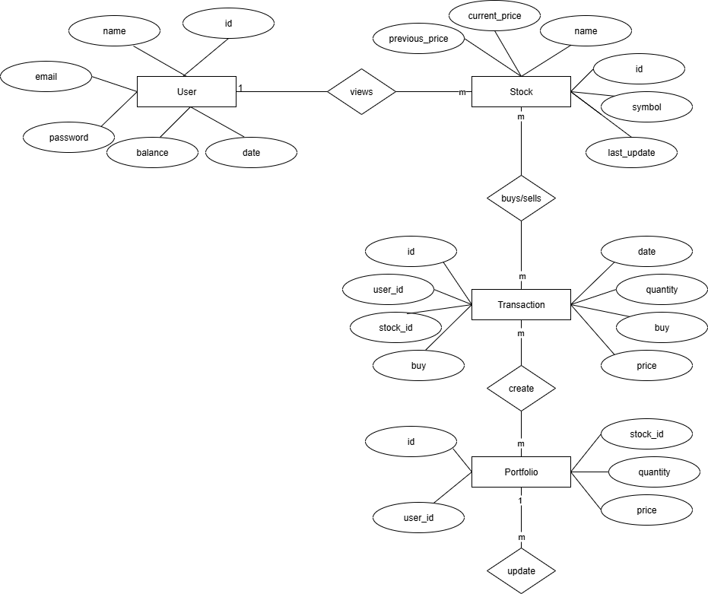

12

**4.2.2 Zero level DFD:**

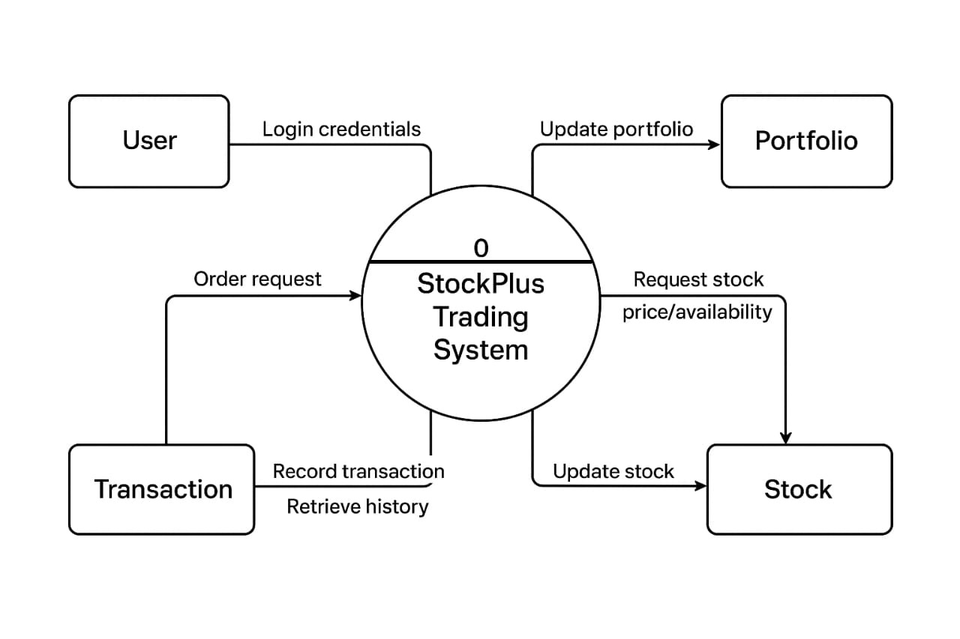

13

**4.2.3 One level DFD:**

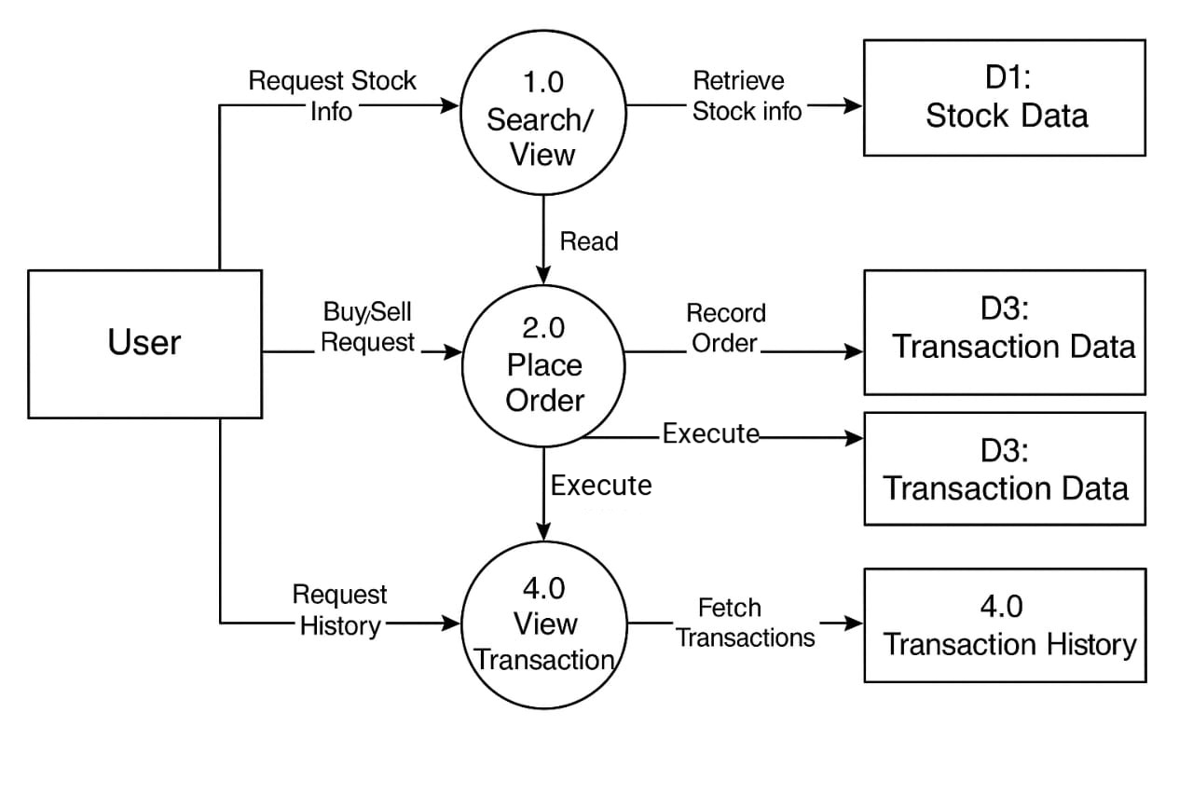

ss

14

**4.3 Data Model :**

**4.3.1 Class Diagram:**

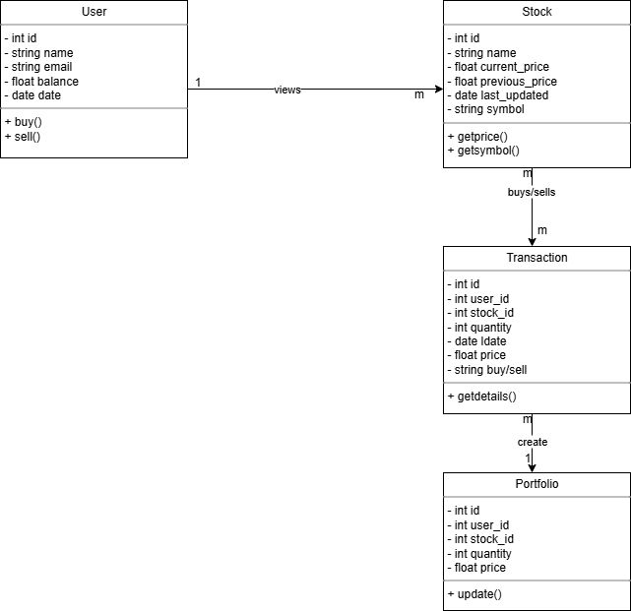

15

**4.3.2 Use Case Diagram:**

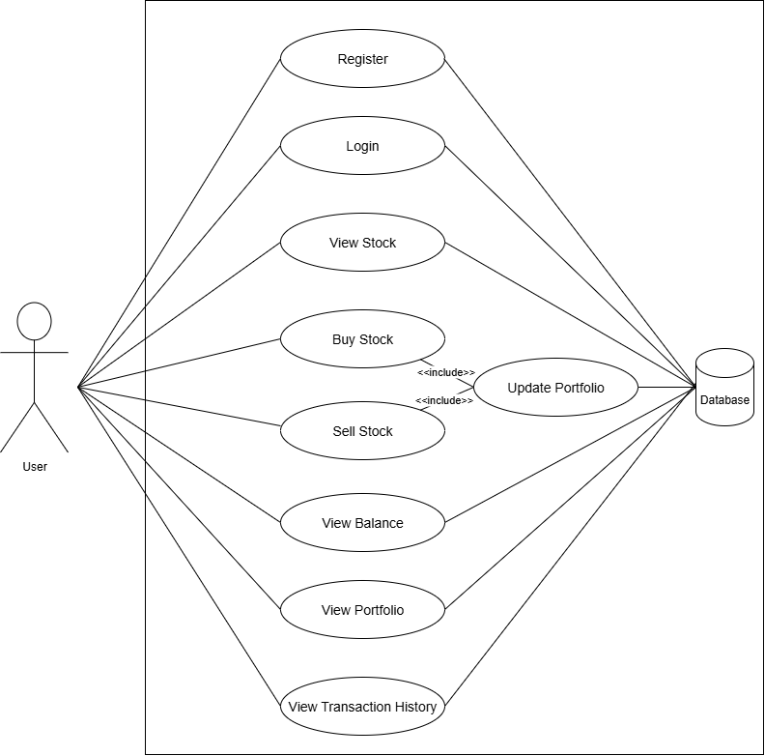

16

**4.3.3 Activity Diagram:**

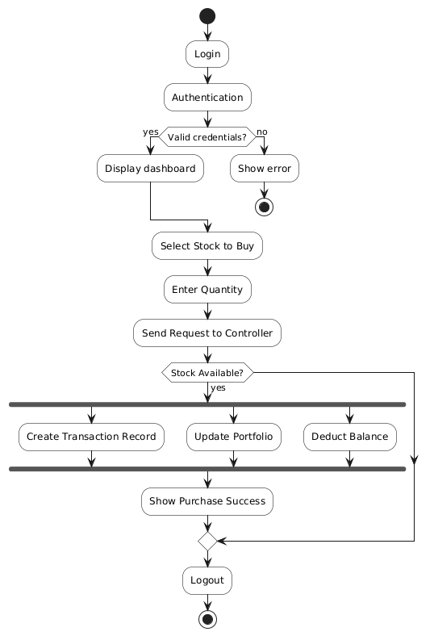

17

**4.3.4 Sequence Diagram:**

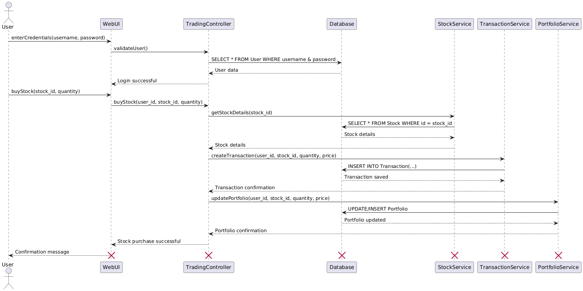

18

**4.3.5 Deployment Diagram:**

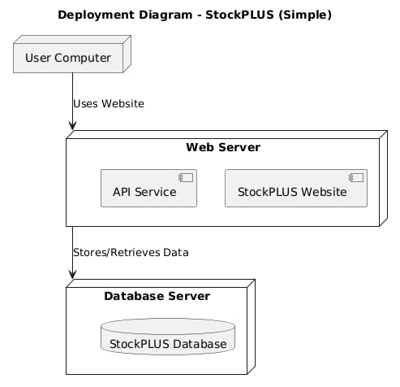

19

**4.3.6 CollaborationDiagram:**

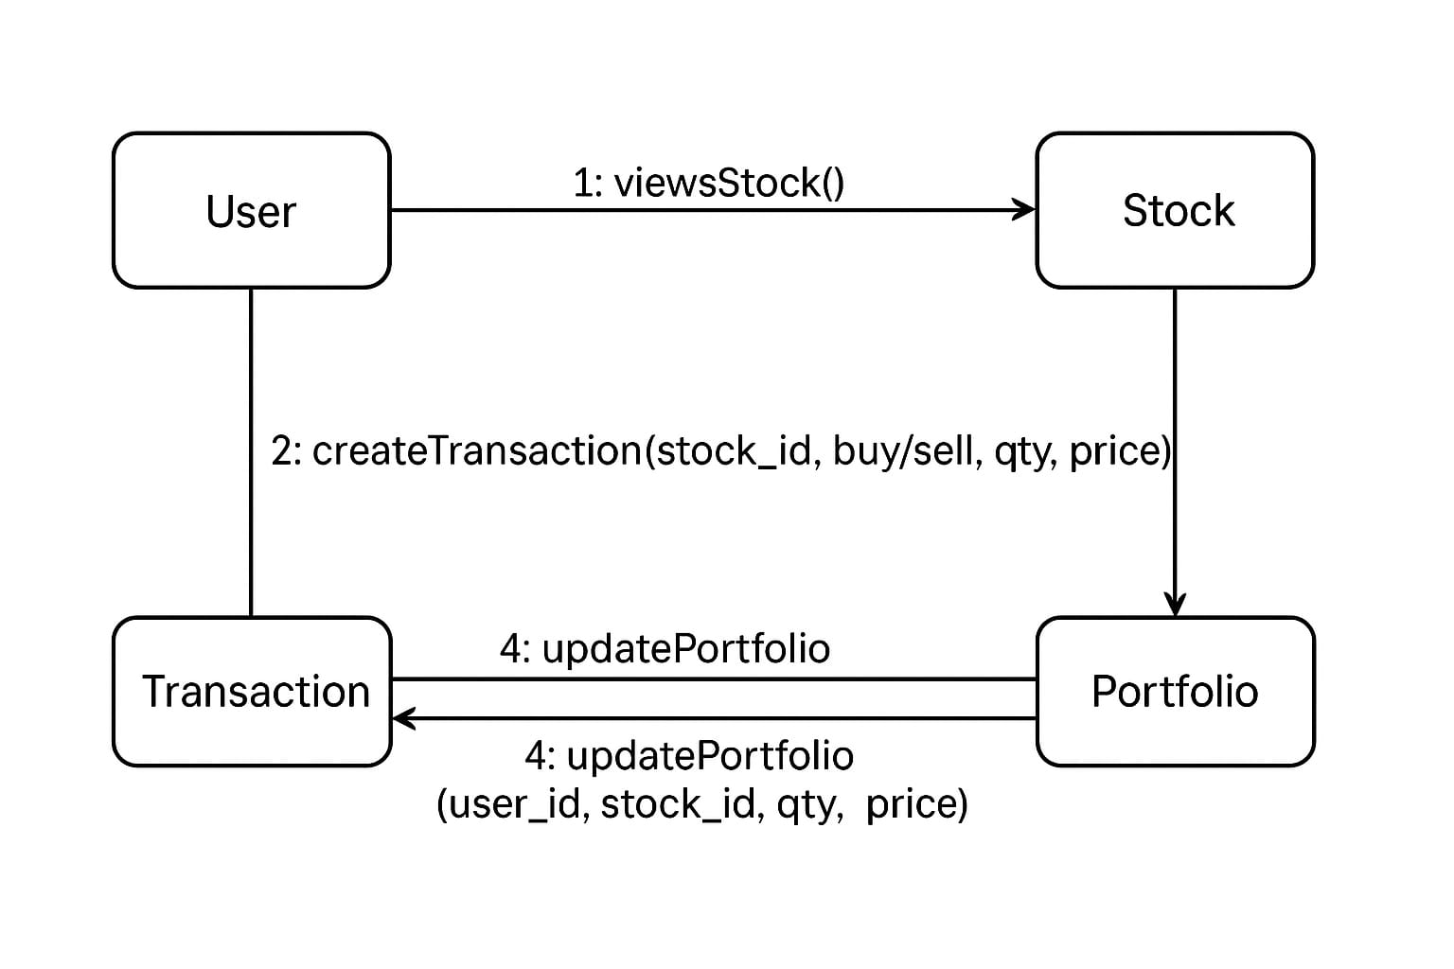

20

**4.4 User Interfaces:**

**4.4.1 Create Account:**

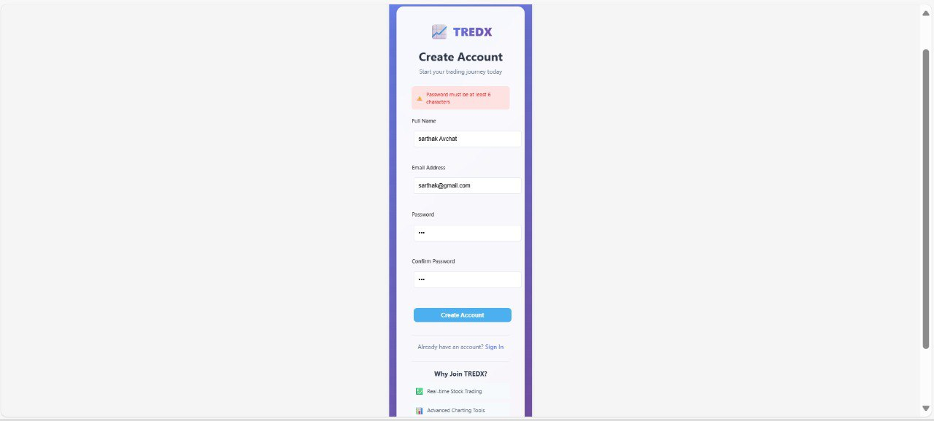

**4.4.2 Login:**

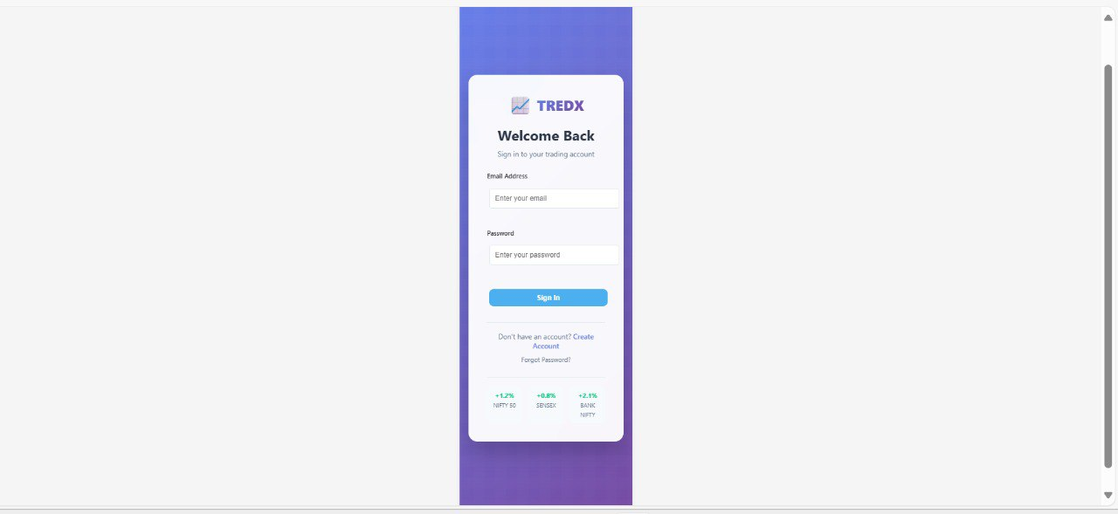

21

**4.4.3 Chart:**

17

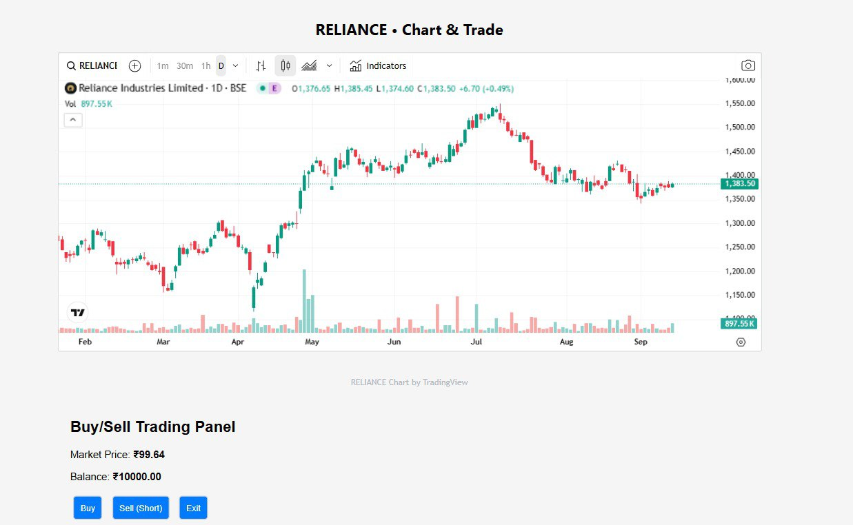

**4.4.4 Trade Stocks:**

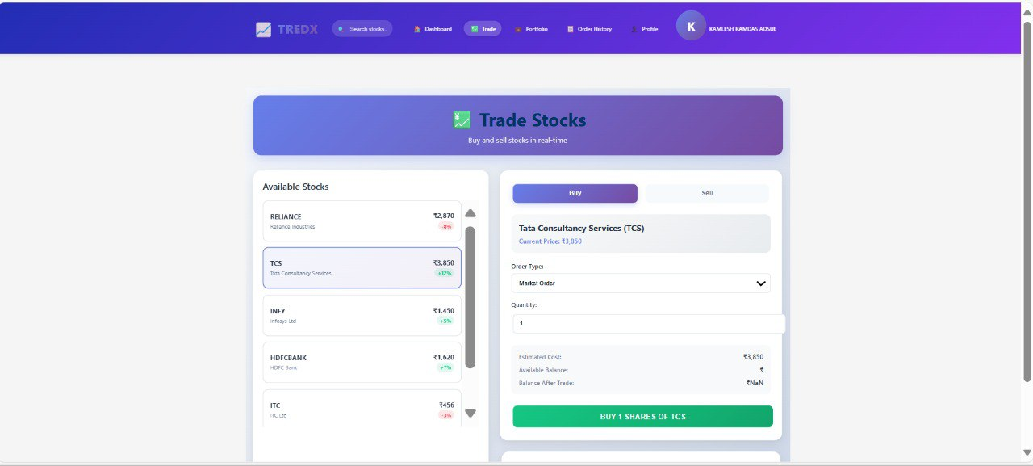

22

15

**4.4.5 Portfolio:**

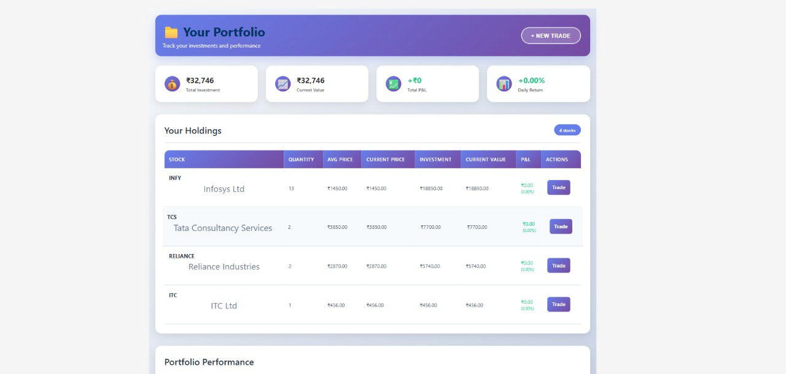

23

16

**CHAPTER 5:**

**IMPLEMENTATION DETAILS**

24

**5.1 Software Requirements;**

|  |  |
| --- | --- |

* Operating System: Windows 10/11, Linux, or macOS
* Frontend: HTML, CSS, JavaScript (optional: React or Bootstrap)
* Backend: Node.js and Express.js
* Database: MongoDB (Atlas)
* Web Server: Node.js runtime (for Node backend)
* Code Editor: Visual Studio Code, Sublime Text, or similar
* Browser: Google Chrome, Firefox, or any modern web browser

**5.2 Hardware Requirements:**

* Processor: Minimum Intel i3 or equivalent (dual-core)
* RAM: Minimum 4 GB (8 GB recommended)
* Storage: At least 250 GB hard disk space
* Display: 13-inch or larger screen
* Internet: Required for API access and online testing
* Input Devices: Keyboard and Mouse

25

**CHAPTER 6:**

**OUTPUTS AND**

**REPORTS TESTING**

26

**6.1 Test Plan**

**6.1.1 Black Box Testing:**

|  |  |  |  |  |  |  |  |
| --- | --- | --- | --- | --- | --- | --- | --- |
| Test Case ID | Test Description | Preconditions | Test Steps | Expected Results | Actual Results | Status | Remarks |
| BB-01 | Check username length | Registration page open | Enter short username | Show username error | Error shown | Pass | OK |
| BB-02 | Check email format | Registration page open | Enter invalid email | Show email error | Error shown | Pass | OK |
| BB-03 | Check password length | Registration page open | Enter short password | Show password error | Error shown | Pass | OK |
| BB-04 | Valid login | User registered | Enter valid login | Dashboard loads | Loaded | Pass | OK |
| BB-05 | Invalid login | User registered | Enter wrong login | Show error | Error shown | Pass | OK |
| BB-06 | Insufficient funds | User logged in | Buy stock with low balance | Show alert | Alert shown | Pass | OK |

**BB-1:** 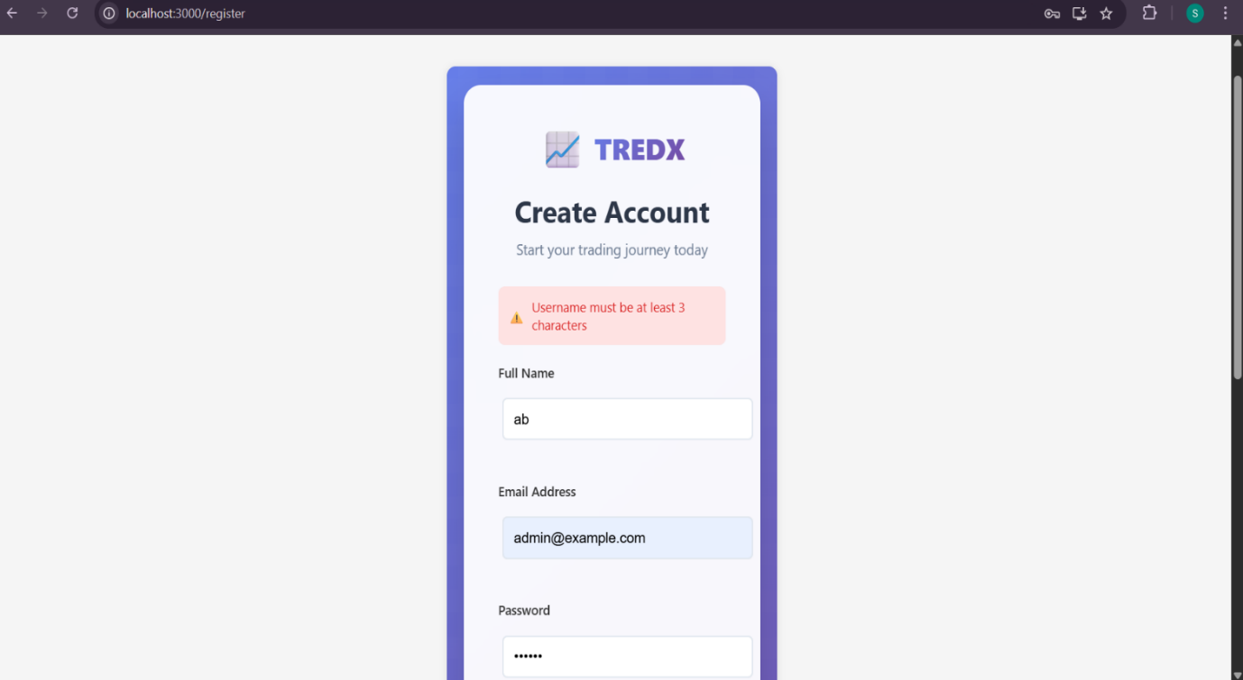

27

**BB-02:**

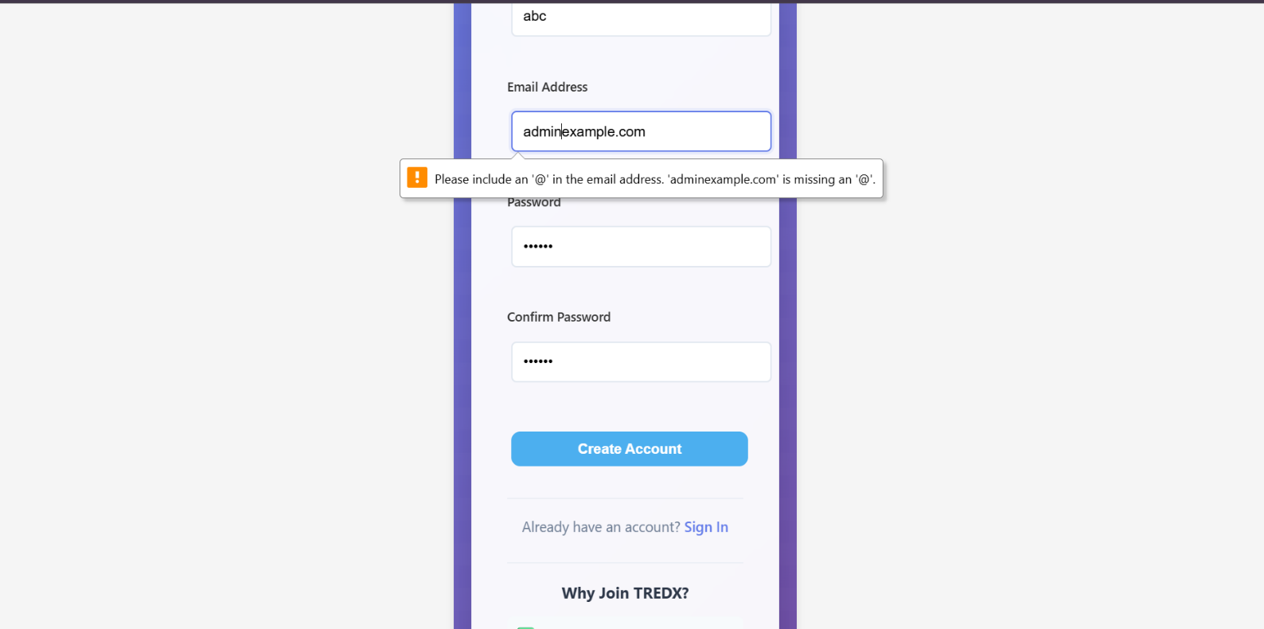

**BB-03:**

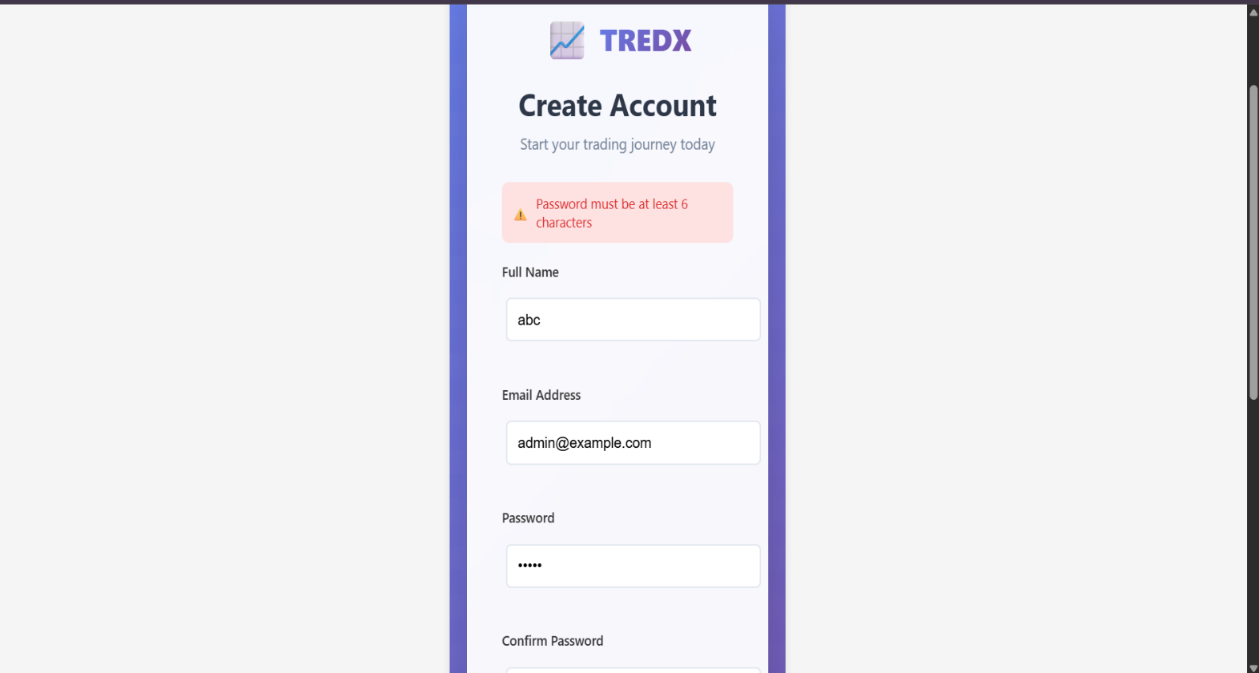

28

**BB-04:**

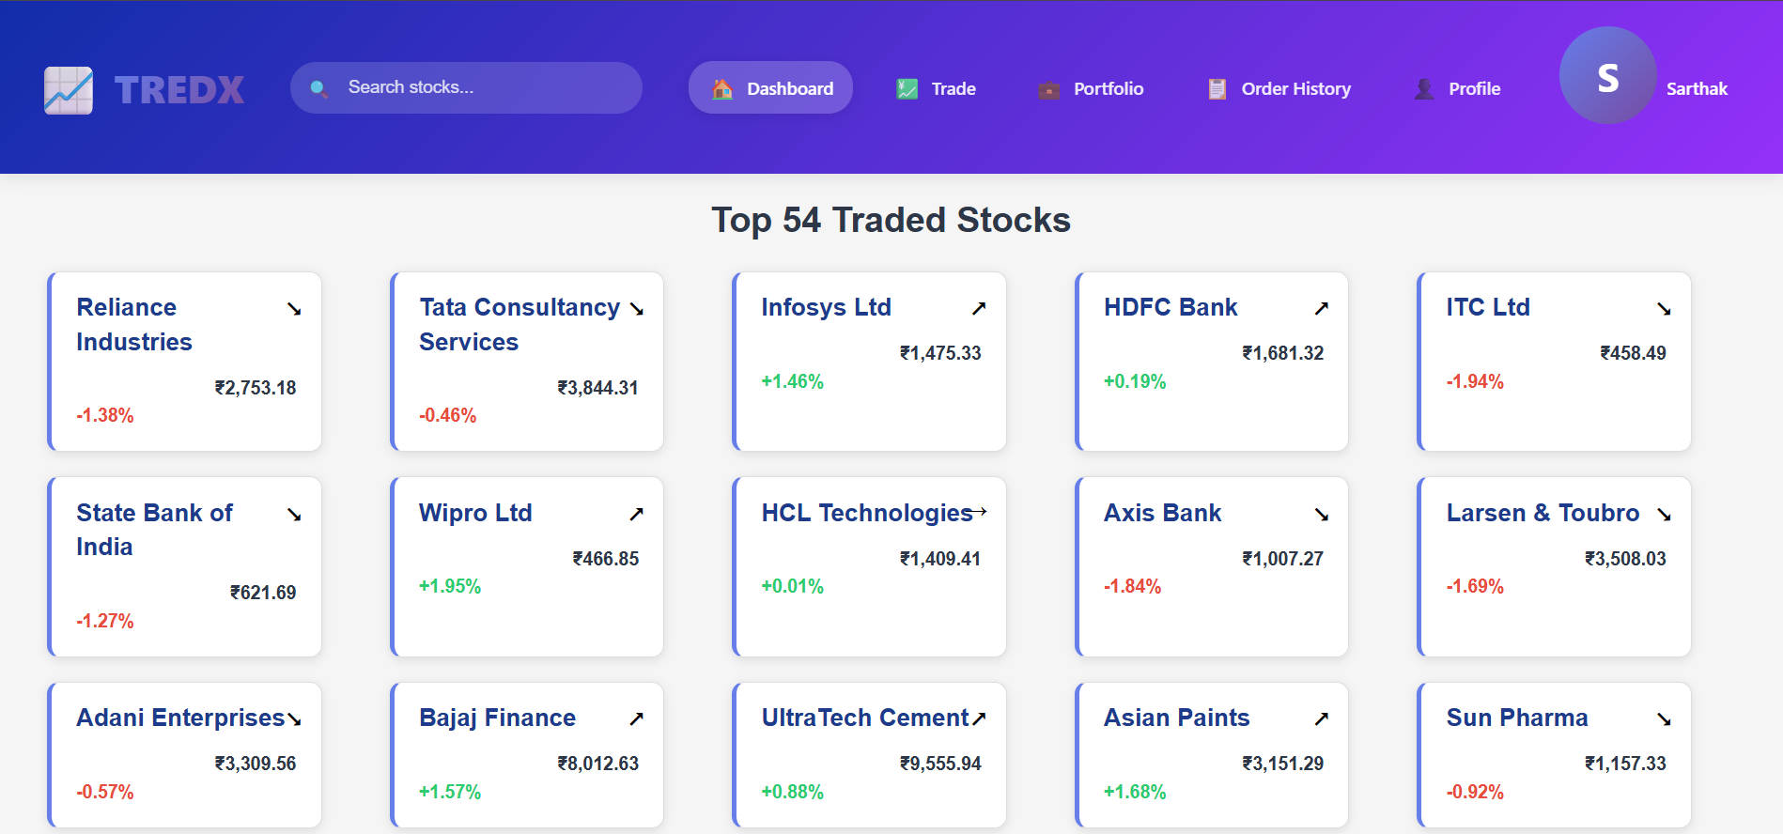

**BB-05:**

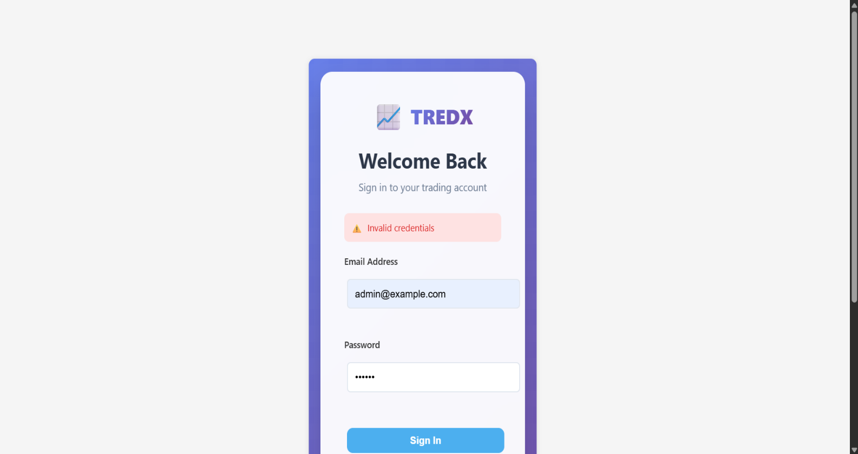

29

**BB-06:**

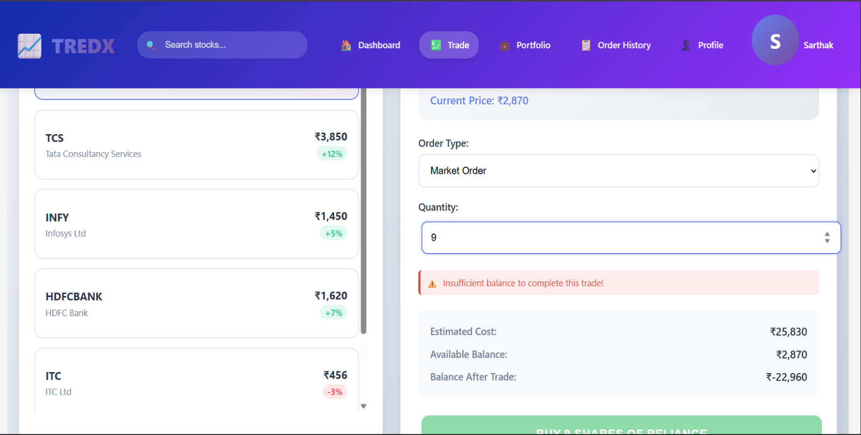

**Issues and Bug Reports:**

|  |  |  |  |  |  |
| --- | --- | --- | --- | --- | --- |
| Issue ID | Description | Severity | Priority | Status | Remarks |
| BB-I01 | Email not validated properly | Medium | High | Fixed | Validation updated |
| BB-I02 | Password accepted spaces | Low | Medium | Fixed | Trim added |
| BB-I03 | Dashboard load delay | Medium | Medium | Resolved | Improved speed |

30

**6.1.2 White Box Testing:**

30

|  |  |  |  |  |  |  |  |
| --- | --- | --- | --- | --- | --- | --- | --- |
| Test Case ID | Test Description | Preconditions | Test Steps | Expected Results | Actual Results | Status | Remarks |
| WB-01 | Successful login | User exists | Enter valid data | Dashboard loads | Loaded | Pass | OK |
| WB-02 | Failed login | Invalid data | Enter wrong password | Show error | Error shown | Pass | OK |
| WB-03 | Profit display | Portfolio ready | View portfolio | Profit in green | Shown | Pass | OK |
| WB-04 | Loss display | Portfolio ready | View portfolio | Loss in red | Shown | Pass | OK |
| WB-05 | Buy stock | Logged-in user | Click buy | Stock added | Added | Pass | OK |
| WB-06 | Sell stock | Owns stock | Click sell | Stock removed | Removed | Pass | OK |

**WB-01:**



31

**WB-02:**

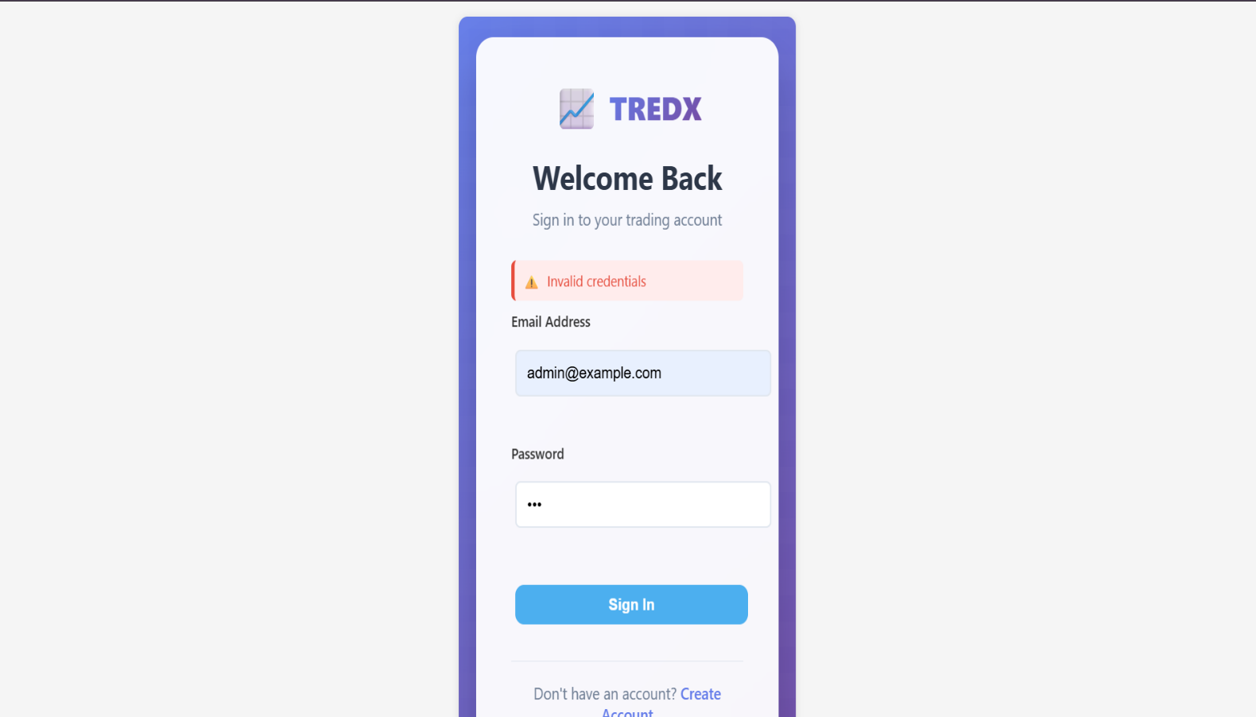

**WB-03:**

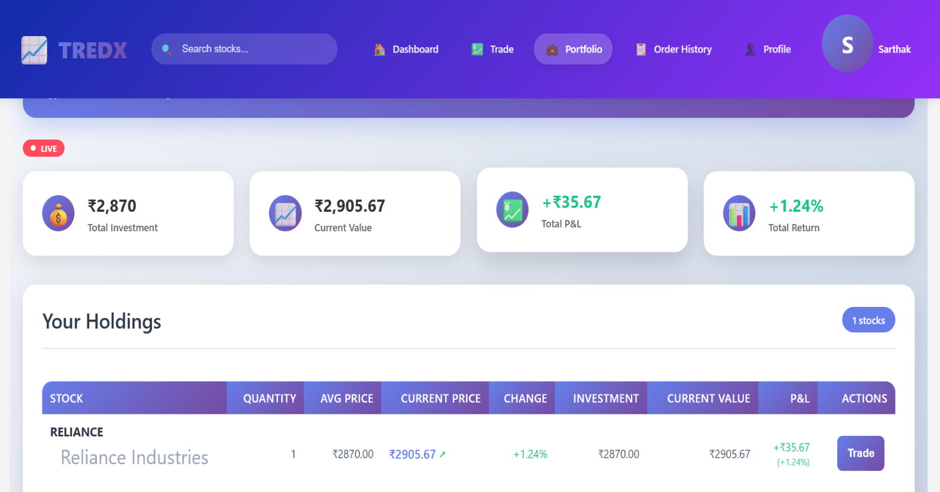

32

**WB-04:**

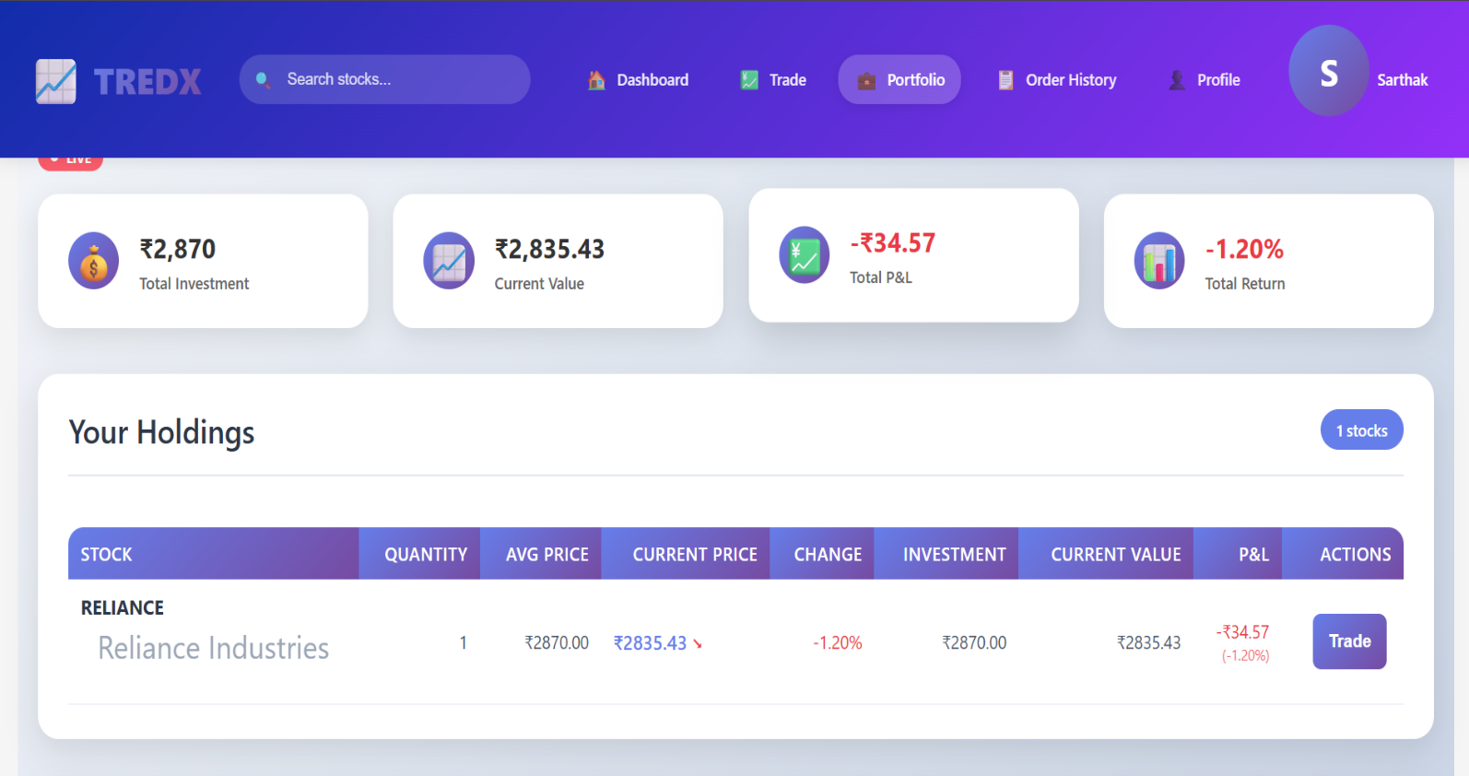

**WB-05:**

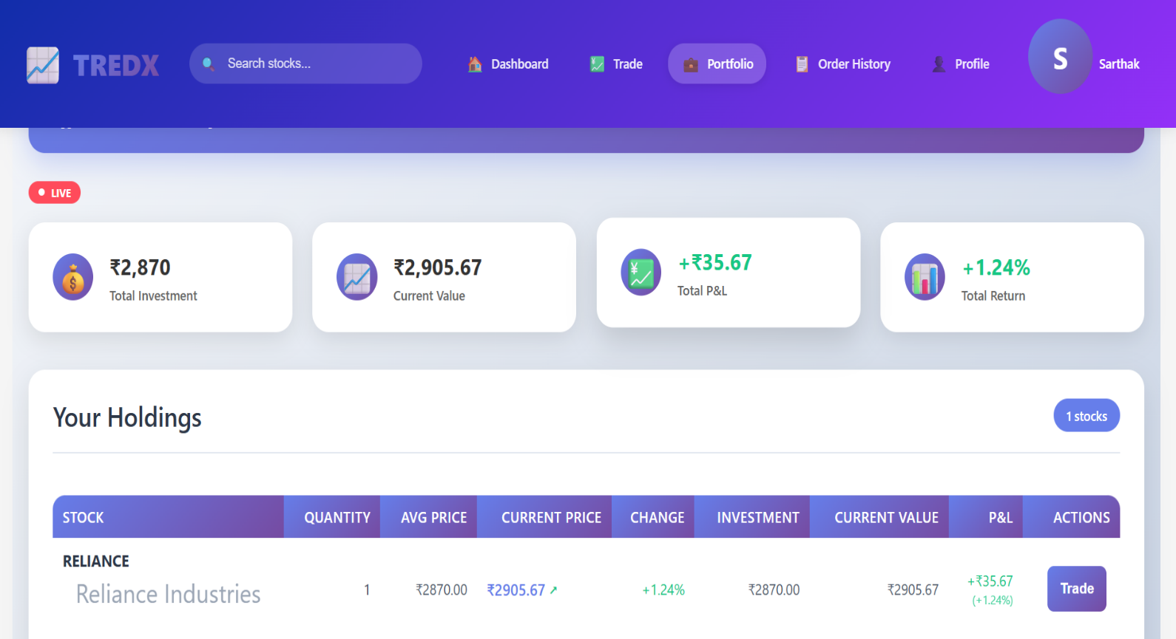

33

**WB-06:**

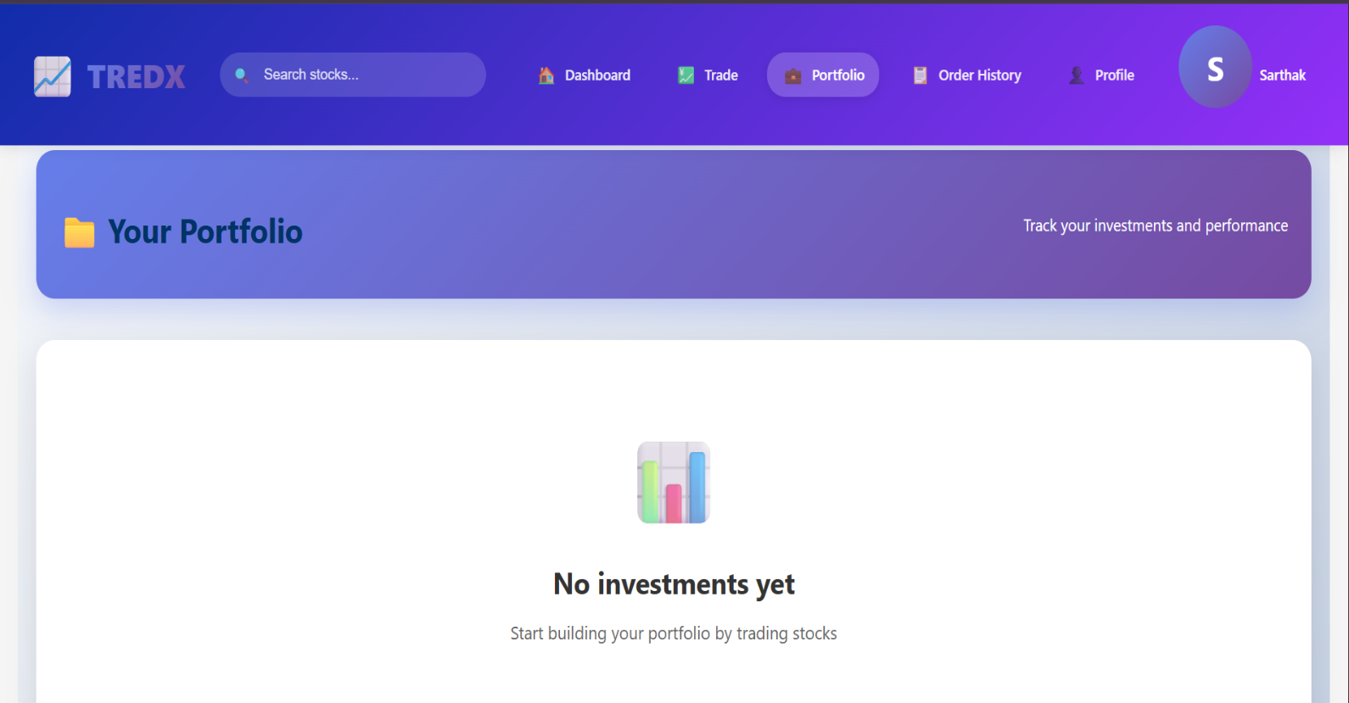

**Issues and Bug Reports:**

|  |  |  |  |  |  |
| --- | --- | --- | --- | --- | --- |
| Issue ID | Description | Severity | Priority | Status | Remarks |
| WB-I01 | Portfolio color not updating | Low | Low | Fixed | Added refresh |
| WB-I02 | Stock not removed after sell | High | High | Fixed | Backend logic corrected |
| WB-I03 | Login delay | Medium | Medium | Resolved | Optimized API |

34

**CHAPTER 7:**

**CONCLUSION**

**AND RECOMMENDATIONS**

35

34

**7.1 Conclusion**

StockPlus is a simple, secure, and user-friendly trading application that helps both beginners and experienced users simulate stock trading. It provides real-time data, portfolio management, and trading features to make learning and practice easier. While this version does not support real-money trading, it creates a strong base for future development into a full trading platform.

**7.2 Recommendations**

In future versions, StockPlus can be improved by adding real trading features through integration with stock brokers and financial APIs. A mobile app version can provide better access and notifications. Security can be strengthened with two-factor authentication and data encryption. More technical indicators and analysis tools should be included for advanced users, while built-in tutorials can help beginners. AI and machine learning can also be used for smart predictions and portfolio suggestions.

36

**CHAPTER 8:**

**FUTURE SCOPE**

37+7

**8.1 Future Scope:**

The **S**tockPlus application is designed with flexibility in mind, allowing it to be improved and expanded in future versions. Below are some possible future enhancements:

* Real-Time Trading Integration:  
  In the future, StockPlus can be connected with actual stock brokerage APIs to allow real-money trading, not just simulation.
* Mobile Application Development:  
  A dedicated Android and iOS mobile app can be developed to improve accessibility and provide real-time alerts and notifications.
* AI-Based Recommendations:  
  Artificial Intelligence and Machine Learning can be used to provide personalized stock suggestions and risk analysis based on user activity.
* News and Market Sentiment Analysis:  
  Integration with financial news and sentiment tracking tools can help users make informed decisions based on real-world events.
* Multi-Currency and International Market Support:  
  Future versions can support international stock exchanges and allow users to trade in multiple currencies.
* Educational Resources:  
  Built-in tutorials, beginner courses, quizzes, and simulations can be added to help users learn how the stock market works.
* Two-Factor Authentication (2FA):  
  Adding extra security features like 2FA will make the platform safer for users.

38

**CHAPTER 9:**

**BIBLIOGRAPHY**

**AND**

**REFERENCES**

39

1

**9.1 References**

* https://www.zerodha.com – For understanding Zerodha's features and trading system
* https://www.upstox.com – For studying Upstox’s user interface and tools
* https://www.groww.in – For learning about beginner-friendly trading apps

40